Chart of Accounts
​

​
Chart of Accounts is used to refer to the organization of all accounts in a financial system.
Navigate to the chart of accounts from the Sidebar: Setup > Chart of Accounts
There are two types of accounts in the Chart of Accounts
- Ledger Accounts: Accounts that are used in the transactional entries and that appear in the General Ledger.
- Group Accounts: Accounts that are used to group other Group and Ledger accounts.

Root Accounts
At the upper most level there are 4 Group Accounts. These can be thought of as the Root Accounts. These Root Accounts have all the other accounts grouped underneath them.
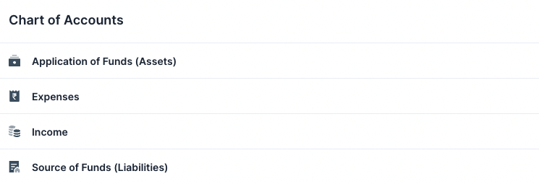
::: info Number of Root Accounts The number of Root Accounts depends on your country's CoA.
For example: The Indian CoA has only 4. Whereas the Standard Chart of Accounts has 5. :::
Each Root Account is either a Credit or a Debit account. If a Root Account is a Credit account all the accounts underneath it will also be a Credit Account. (Credit and Debit)

Other Accounts
Clicking on a Root Account will reveal the accounts other it. This goes for the other Group Accounts too.
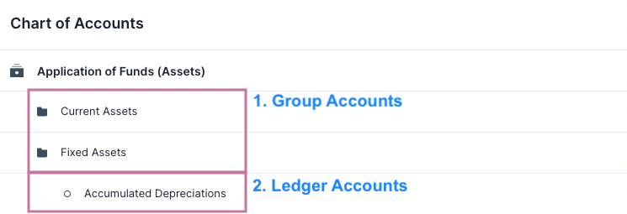
Clicking on a Ledger Account will open that accounts Quick Edit Form where the details of the account can be viewed.
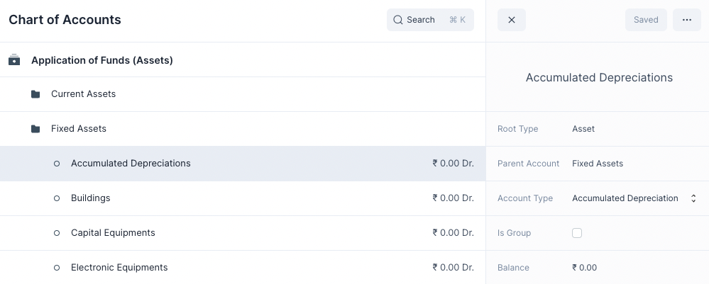

Creating a New Account
To create a new account
- Hover over a Group Account
- Click on Add Account or Add Group
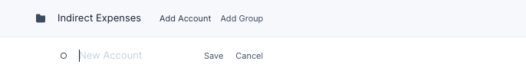

This will display a new row where you can enter the account name. After you are done press Save to create the account.
Setup Opening Balances
​

​
If you are moving from an existing accounting system over to Nirolite , you will need to enter the account balances from your previous system.
To set the Opening Balances you can follow the steps below.
Get the starting balances from your previous accounting system in the form of Trial Balances report.

Add Additional Accounts
Add any accounts from your previous system that do not exist in Nirolite by navigating to the Chart of Accounts.
You can follow the steps shown here. Make sure you create the Accounts under the correct Account groups.

Create a Journal Entry
First navigate to the Journal Entry page.
Common > Journal Entry
Then click on the blue + button to open the Journal Entry form.

- Set the Entry Type as Opening Entry.
- Add a row for each line from your Trial Balances report, select the appropriate Account and the Debit or Credit amount.
- Click on Save. Review it once before clicking on Submit.
You can set a Reference Number and Reference Date to mark the entry.
This will create a Journal Transaction in the system with all your previous statements.
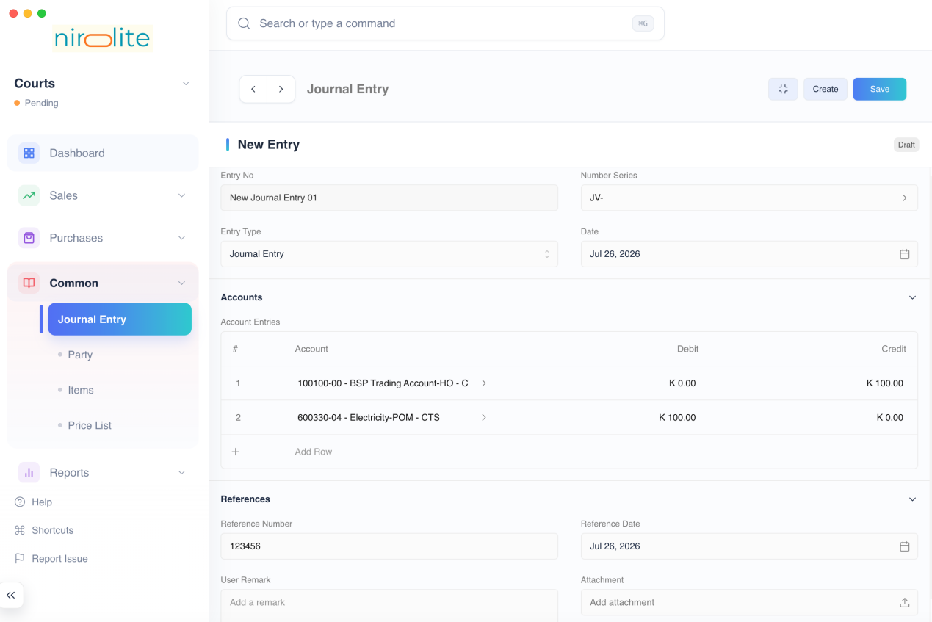
Congratulations! You have now set your Opening Balances. 🎉
This brings your to the same position that was present in your previous accounting system.
You are now ready to record your business activities by making transactions.

Create Initial Entries
​

​
Let’s create some initial entries before you can start recording your transactions.

Add Additional Bank Accounts
Add any bank accounts your business has apart from the one already added in the Setup.
Navigate to the Chart of Accounts page from the sidebar.
Setup > Chart of Accounts
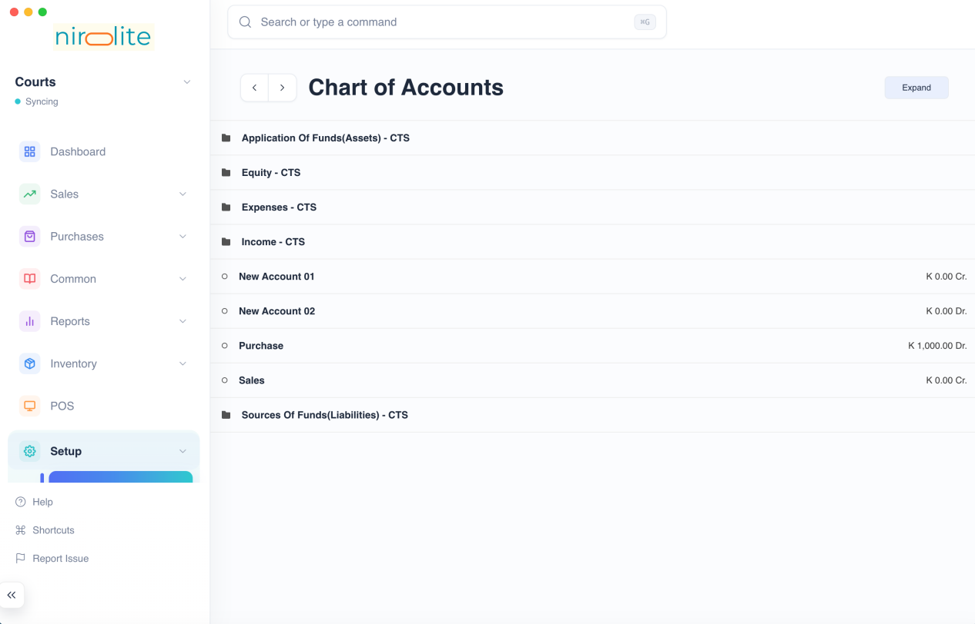
Then open the Bank Accounts group and click on Add Account.
Application of Funds (Assets) > Current Assets > Bank Accounts > Add Account
Enter the bank account name and press enter to create it. You can now transfer funds in and out of this bank account.

Add Taxes
If your company charges or will recover Sales Taxes, add any taxes that you will use. First navigate to the Taxes page.
Setup > Taxes
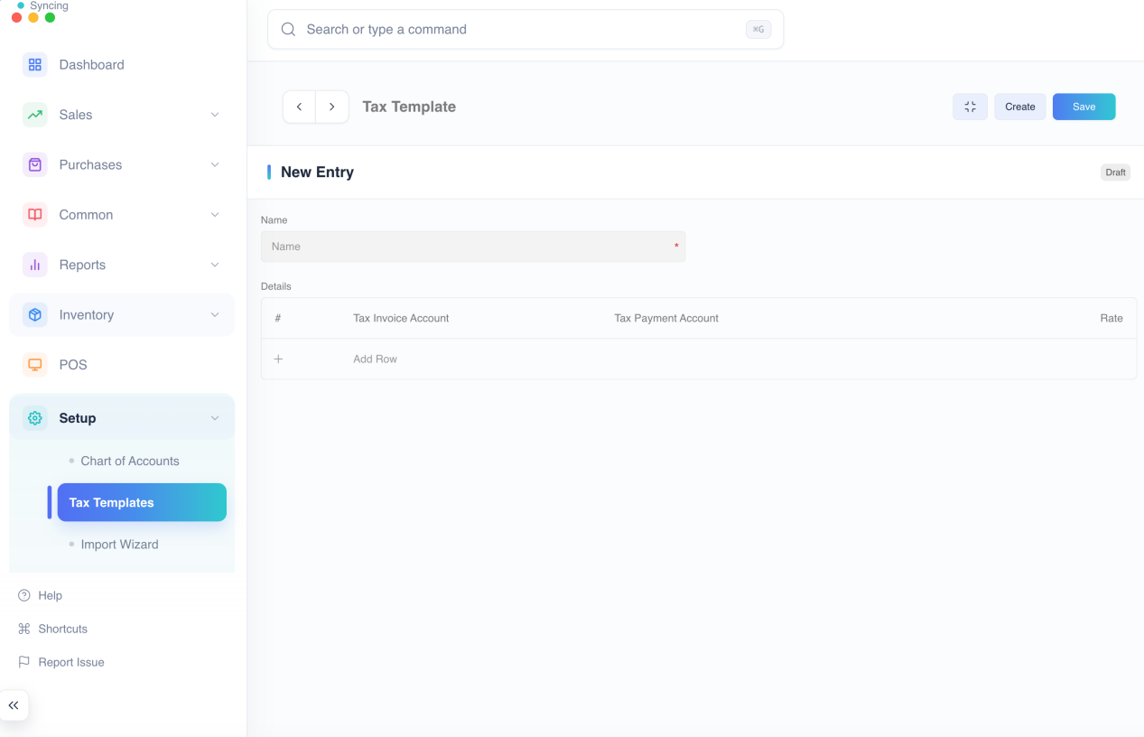
- Create a New Tax Entry: Click on the blue + button. Enter a name which will make it easier to identify. You can also mention the rate in the name. for e.g. Service Tax - 5%.
- Select the Tax Account and Rate: You can add multiple rows with different Tax Accounts. This will make it easier to apply a set of Taxes which are frequently applied together on an Item. You can even create different taxes for different Items or a class of Items.
- Click on Save
For more information on Taxes in Nirolite click here.

Add Sales Items
One of the most important things you will add in are your products or services that you provide to your customers. Navigate to Sales Items
Sales > Sales Items
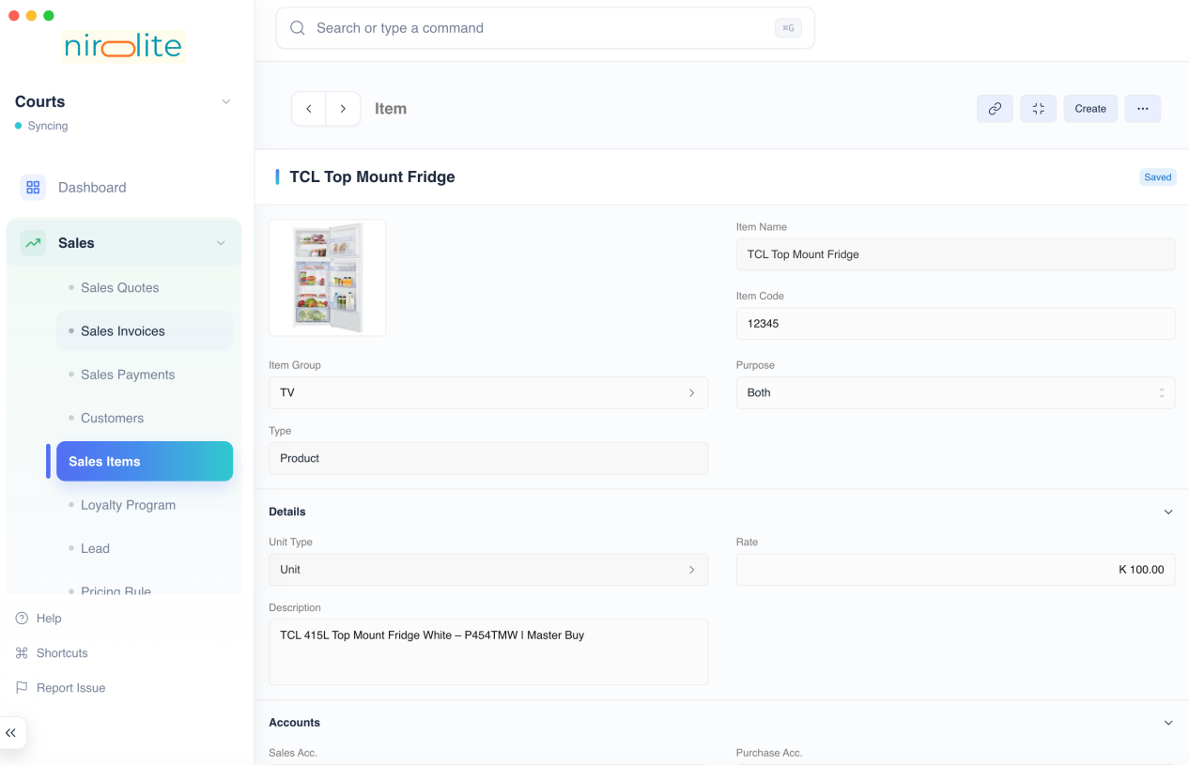
- Create a New Item Entry: Click on the blue + button. Enter the Name and the Rate
- Select Type: Select if your Item is a Product or Service.
- Set Default Tax: Setting the default Tax for your Item will fetch it automatically when you create an Invoice.
- Click on Save
You can set or change the other details for the item. Such as the Income or Expense accounts.
You can even set an image for the item.
For more information on Sales Items in Nirolite click here.

Add Customers
Add your Customers to record their details and select them in Sales Invoices. First navigate to Customers
Sales > Customers
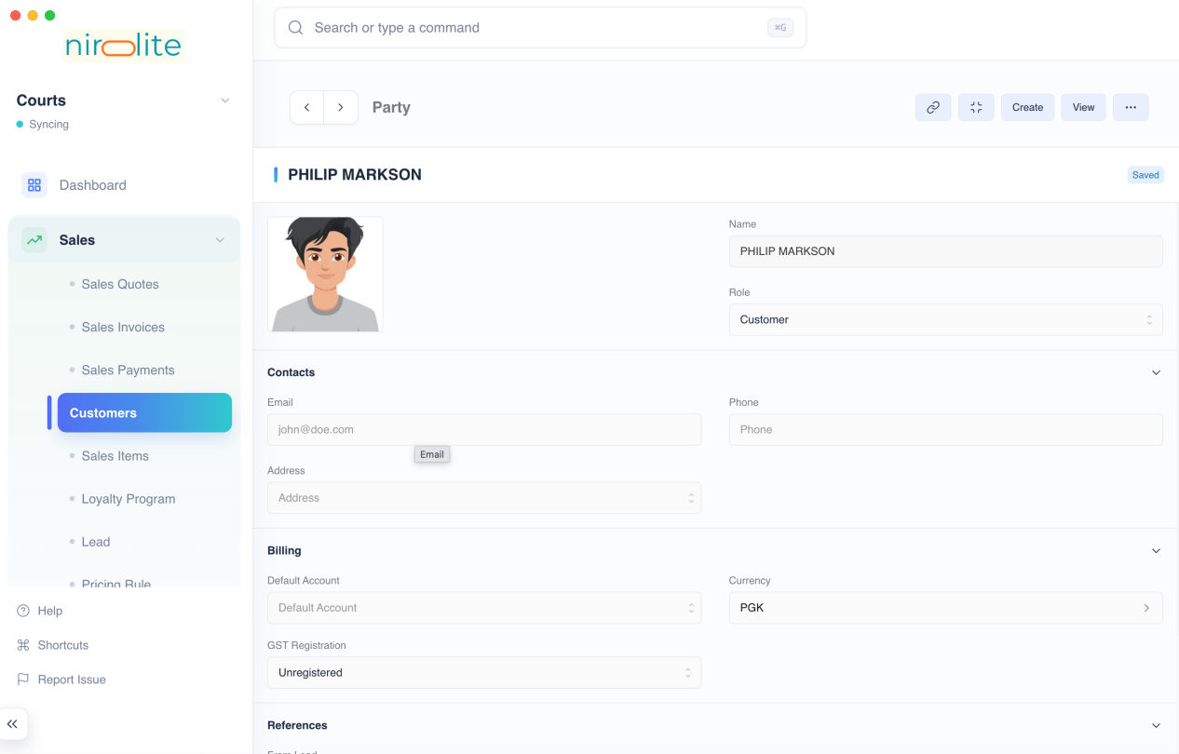
- Create a New Customer Entry: Click on the blue + button. Enter the name of of the customer
- Click on Save
You can enter additional details such as Email and Phone in the Customer entry. This will be shown when creating a Sales Invoice PDF.
For more information on Customers in Nirolite click here.
You can now move onto the next step to set your Opening Balances.

Import Wizard
​

​
The Import Wizard is a powerful tool that can allow you to:
- Import Data from a .csv file
- Make multiple entries quickly

Basics
To use the Import Wizard navigate to it using the sidebar: Setup > Import Wizard. Or alternatively open the Quick Search, type "Import Wizard" and hit enter.

The Interface
Once the Import Wizard has been opened you will have to select and Import Type which decides the kind of entries to be imported.
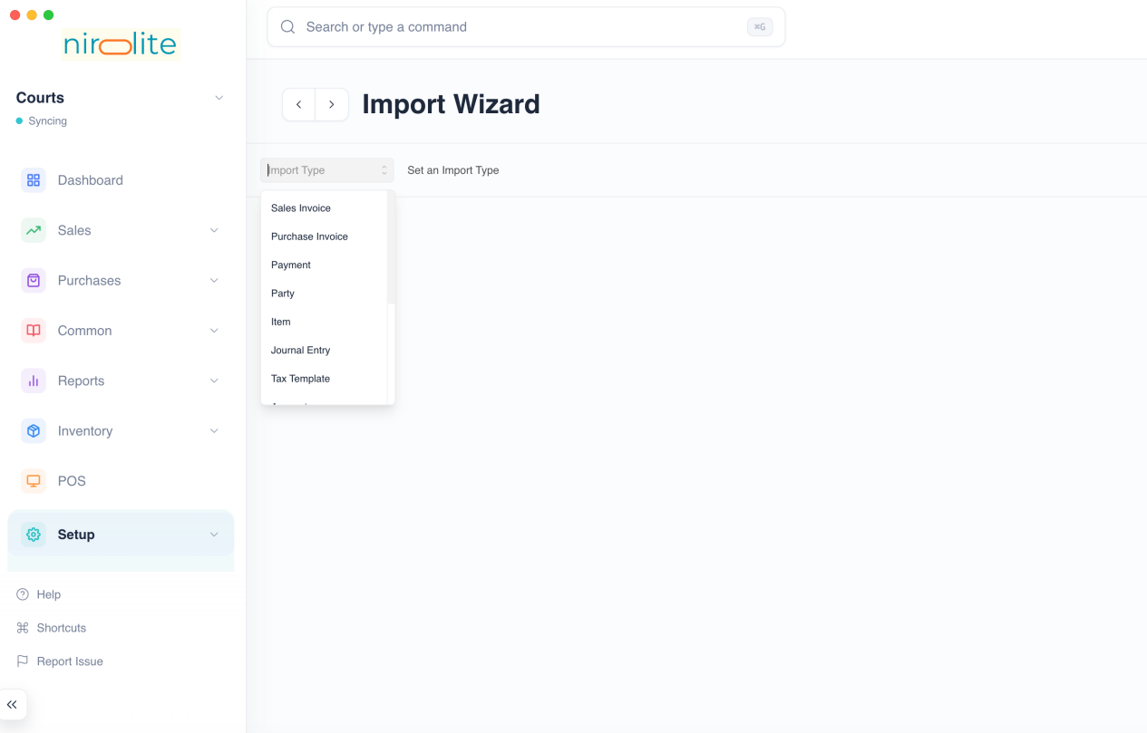
After selecting the import type, you'll see the additional controls that are now available.
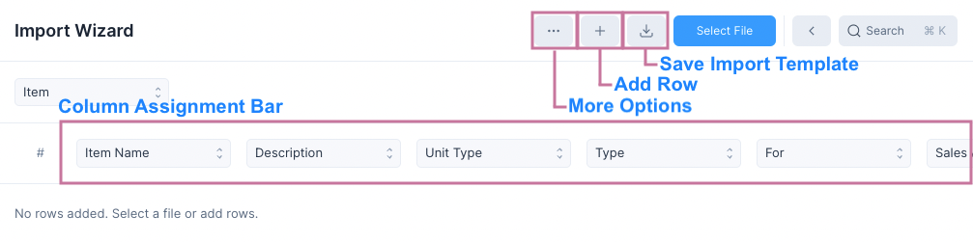

Using a Template
To import data you, it needs to fit some template for this, first click on the Save Import Template button.
This will download a .csv template file.
:::tip The Template.csv file The Template.csv file can be filled using any spreadsheet software.
The Import Template has three rows:
- Entry type row: Some entries have child tables and this indicates whether the column belongs to the child table.
- Field label row: This tells us which field of the entry (or its child table) does the column belong to.
- Field key row: This row allows the Import Wizard to auto assign the columns when the file is selected. If this row is not present then Column Assignment Bar can be used to assign the fields.
:::
To use the Template.csv file you must
- Import it into your spreadsheet software of choice
- Enter the values in the spreadsheet cells
- Export the sheet as a .csv file
Once you have exported the .csv file, click on Select File to select the file. The Import Wizard will read the file and add rows to the table.

Verifying and Importing
You can now check the imported values and if everything seems right. If you want to remove a row, click on the row index to delete it.
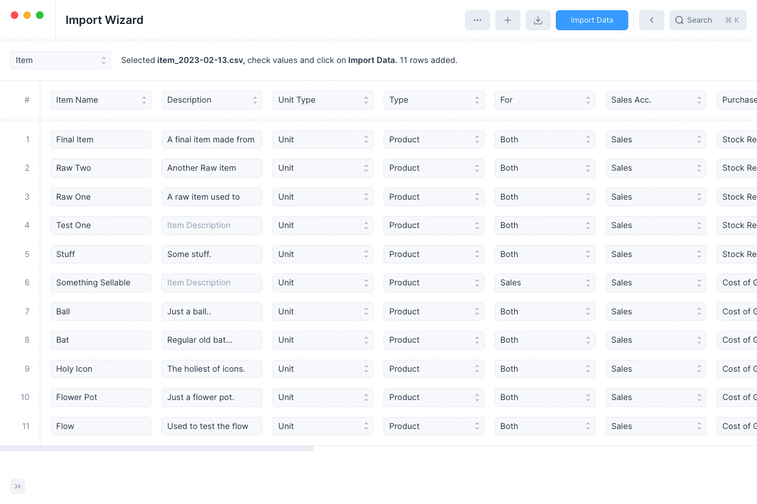
:::tip The Add Row button You can click on the Add Row button to add an additional empty row to the bottom of the import table which can be edited to enter the required values.
This feature can be used for making multiple entries quickly without even selecting a file. :::
:::info Fixing Conversion Errors If the Import Wizard couldn't convert a value then it will be marked with a red border.
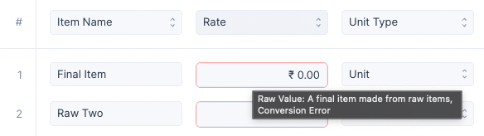
You can hover over the field to view what the raw value was and fix the value to remove the error :::
Finally if everything is fine, click on Import Data to begin importing the data.

After Importing
Once import is done, you'll see the Import Complete modal
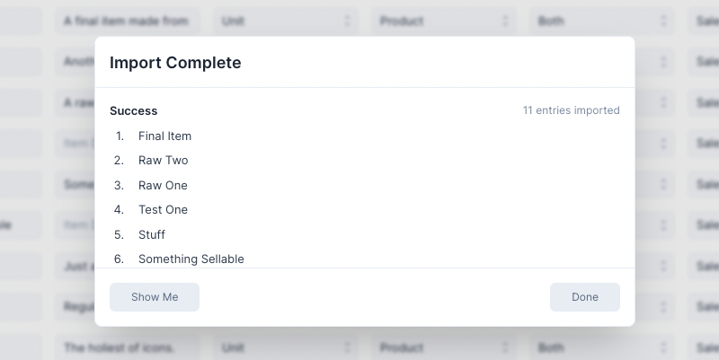
Clicking on Show Me will take you to the List View of the newly created entries. Clicking on Done will reset the Import Wizard allowing you to make more entries.
:::info Fixing Failed Imports If certain entries could not be imported then you can click on the Fix Failed button that is visible only on failed imports.
Clicking it will clear all the successful imports and allow you to fix the failed ones and retry. :::

Picking Import Columns
You can pick the specific columns you want to import by clicking on the ...button and then clicking on Pick Import Columns.
This will open the Pick Import Columns modal
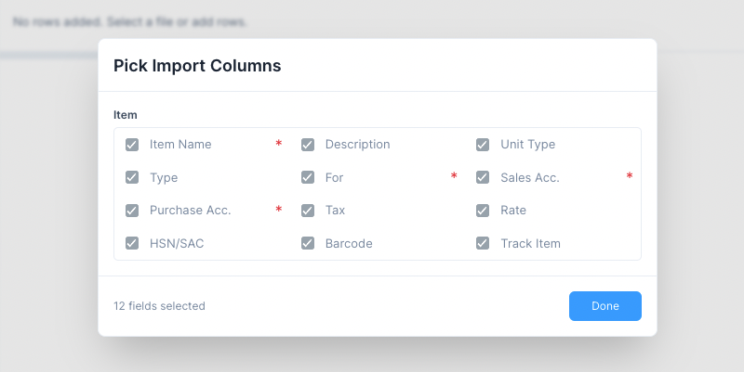
The fields marked by the red * are required fields and cannot be unselected. Other than these you can choose to keep or remove the rest of the columns.
Removing a column will:
- Remove it from the exported template.
- Prevent it from being assigned to a column.

Column Assignment Bar
The Column Assignment Bar is used to mark a column in the table as a certain field. This is useful if the file you have selected doesn't use the Import Wizard's template.
Along with assigning columns you can even de-assign columns by selecting None 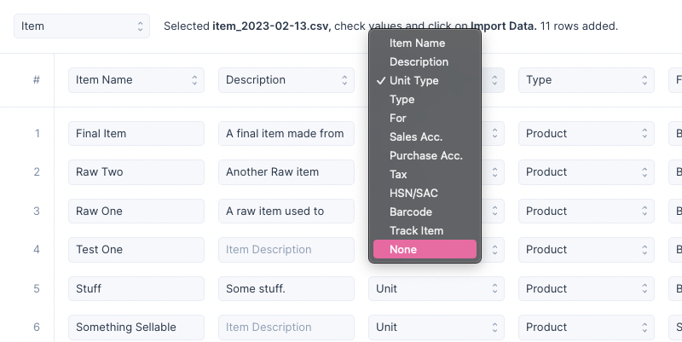
If None is selected then that column is ignored while importing data.

Importing Entries with Child Tables
Sales Invoice is an example of an entry with a child table. Here child table refers to the items table which lists all the items included in the sale.
When importing entry with a child table:
- Unique placeholder names should be provided even if the entry uses a Number Series.
- Each row in the child table should be one row.
- All rows of an entry should have the same non child table row data.
For Example
Invoice Name | Customer | Item (Table Row) | Amount (Table Row)
A | Lin | Bat | 100
A | Lin | Ball | 50
B | Andy | Pen | 200
B | Andy | Pencil | 10
B | Andy | Ink | 80
Here the import table has two Sales Invoices with unique names A, and B.
Invoice A has two items and Invoice B has three items. Each item is a single row in the import table.
And for every child table row in the import table the non child table data, i.e. Invoice Name and Customer are repeated.
::: warning Not following these guidelines may either cause the data to not be imported properly or to fail altogether. :::

Quick Search
​

​
The Quick Search interface is a quick way to navigate around in Nirolite . To activate it you can click on the search button in the header:
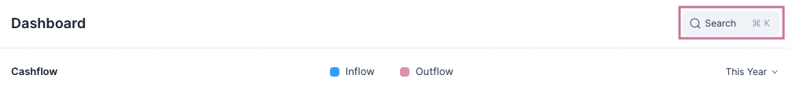
Or you can press Ctrl + K or Cmd + K depending on your operating system.

Dialog
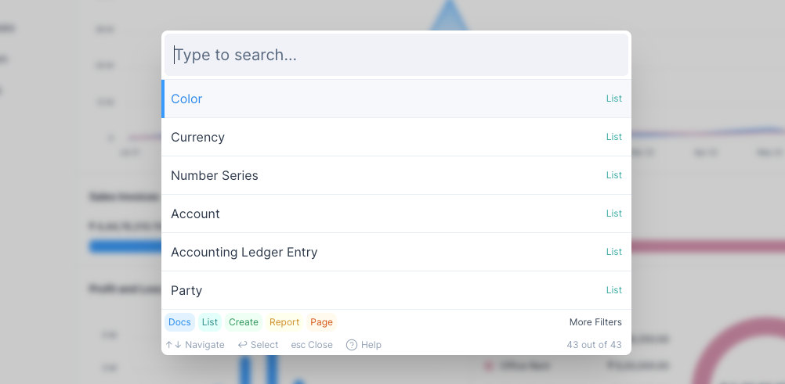
To search for anything type what you are looking for in the input bar at the top.
::: tip Fuzzy Search Because of the fuzzy search method used, you don't have to type the exact name of the thing you are searching.
So if you make spelling mistakes it is fine, you will still find what you are looking for. :::
Each row in the search results is classified as one of the following Types:
# | Type | Color | Purpose | Example
1 | Docs* | blue | Opens the selected entry | PAY-1001
2 | List | teal | Opens the List View | Sales Items
3 | Create | green | Opens a Form or Quick Edit Form to create an entry | Purchase Invoice
4 | Report | yellow | Opens the selected report | General Ledger
5 | Page | red | Opens the page | Dashboard
::: info Docs* Rows of the Docs type will show they type of entry it is. For example, Item or Purchase Invoice. :::
In the bottom section you will find the filters which will help you narrow your search results.

Filters
Clicking on More Filters will display all the filters.
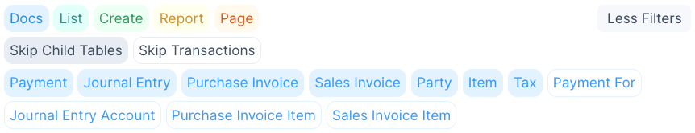
There are two kinds of filters here.
- Regular Filters: coloured buttons in the first row.
- Doc Filters: blue coloured buttons after the first row.
::: tip Skip Filters Skip Child Tables and Skip Transactions are used to toggle multiple Doc Filters at once. :::

Regular Filters
Clicking on one of the regular filters will exclude that type from the search.
For example, if you unselect Doc then only List, Create, Report and Page type rows will show in the suggestions.

Doc Filters
Clicking on a Doc filter will exclude that kind of entry from the search.
For example, if you unselect Payment, all Payments will be excluded from the search.

Examples
The Quick Search functionality is very powerful, you can run various kind of queries just by entering a few letters.
Here are a few examples.
- Finding all the Sales Invoices created for Karen 2. Finding all the Purchases Invoices with the item Jacket 3. Finding the Payment for Purchase Invoice PINV-1099 4. Finding all Payments received from Jack
::: tip Keyword Order The order of the keyword doesn't matter. You can enter the search keywords in any order. :::

Accounting Basics
​

​
A small primer to get you up to speed on the concepts of accounting.
Let's understand the concept of accounting with the example of an imaginary business that is just starting out.
Owner Investment: Let’s say we’re starting a Home Interior business and we have ₹5,00,000 of capital to start our business.
Bank balance will initially be ₹5,00,000.
First Expense: We will need an operating place where we can work and meet clients. For this, we rent out a co-working space for ₹40,000 per month. This is our first expense.
Bank balance will now be ₹5,00,000 - ₹40,000 = ₹4,60,000.
First Income: We have invested some cash, and we have a working place. Now we make our first sale having a value of ₹30,000. We earned ₹30,000 from our first customer. This is our first income.
Bank balance at this point will be ₹4,60,000 + ₹30,000 = ₹4,90,000.
Accounts Payable: Finally, Let’s say we decided to hire a Web Agency to build a website for us, they charge ₹50,000 which will be paid after 2 months from current date.
At this point we haven’t paid them any money, but we are liable to pay them in the future. This is a liability and will be recorded under Accounts Payable.

Events and Accounts
Let’s list these events down in a table:
# | Event | Amount
1 | Owner Investment | + ₹5,00,000
2 | Rent | - ₹40,000
3 | Sales | + ₹30,000
4 | Accounts Payable | - ₹50,000
5 | Total | ₹4,40,000
Now, let's categorize these into the five types of Accounts and list their final balances:
# | Account | Amount
1 | Asset (Bank) | ₹4,90,000
2 | Liabilities (Accounts Payable) | ₹50,000
3 | Equity (Owner Investment) | ₹5,00,000
4 | Income (Sales) | ₹30,000
5 | Expense (Rent) | ₹40,000

Impact on Accounts
Let’s take a look at each transaction and understand which accounts will get affected, from an accounting point-of-view:

1. Cash Investment
Since you, the owner, invested money into the business, it is a liability. So, Accounts Payable, which is a Liability account, is increased by ₹5,00,000.
Also, the money in the Bank Account, which is an Asset account, is increased by ₹5,00,000.
Account | Credit | Debit
Accounts Payable | ₹5,00,000 | 0
Bank Account | 0 | ₹5,00,000

2. Rent
Rent is an immediate expense, so it is recorded in the Rent Account, which is an Expense account, it is increased by ₹40,000.
Also, the money is spent from the Bank Account, which is an Asset account, it is decreased by ₹40,000.
Account | Credit | Debit
Rent Account | 0 | ₹40,000
Bank Account | ₹40,000 | 0

3. First Sale
We got an immediate payment, it is recorded in Sales Account, which is an Income account, the balance is increased by ₹30,000.
Also, we received the money in our Bank Account directly, so it’s balance increases by ₹30,000.
Account | Credit | Debit
Income Account | ₹30,000 | 0
Bank Account | 0 | ₹30,000

4. Hiring a Web Agency
We hired a Web Agency for some work, and we are liable to pay them in the future. This is recorded in Accounts Payable by increasing the amount by ₹50,000.
Since this is an expense for us, we also increase the balance in the Vendor Expense Account by ₹50,000.
Account | Credit | Debit
Accounts Payable | ₹50,000 | 0
Expense Account | 0 | ₹50,000
As you might have noticed, every transaction we do in our business affects two accounts. This is the basis of double-entry bookkeeping system.
You can test this out by creating a Sales Invoice in Nirolite , and then check the General Ledger Report to see which accounts were affected.

Credit and Debit
The words Credit and Debit mean different things when applied to different accounts.
- For Assets and Expense accounts Credit implies a decrease in balance and Debit implies an increase in balance.
- For Liabilities and Income accounts Credit implies an increase in balance and Debit implies and decrease in balance.
::: tip AEDLIC You can remember this by the abbreviation AEDLIC which would stand for:
Assets and Expenses Debit, Liabilities and Income Credit :::

Dashboard
​​
Dashboard show an overview of Cash Flow, Profit and Loss, Pending Payments and Expenses.
You can access the Dashboard from the sidebar.
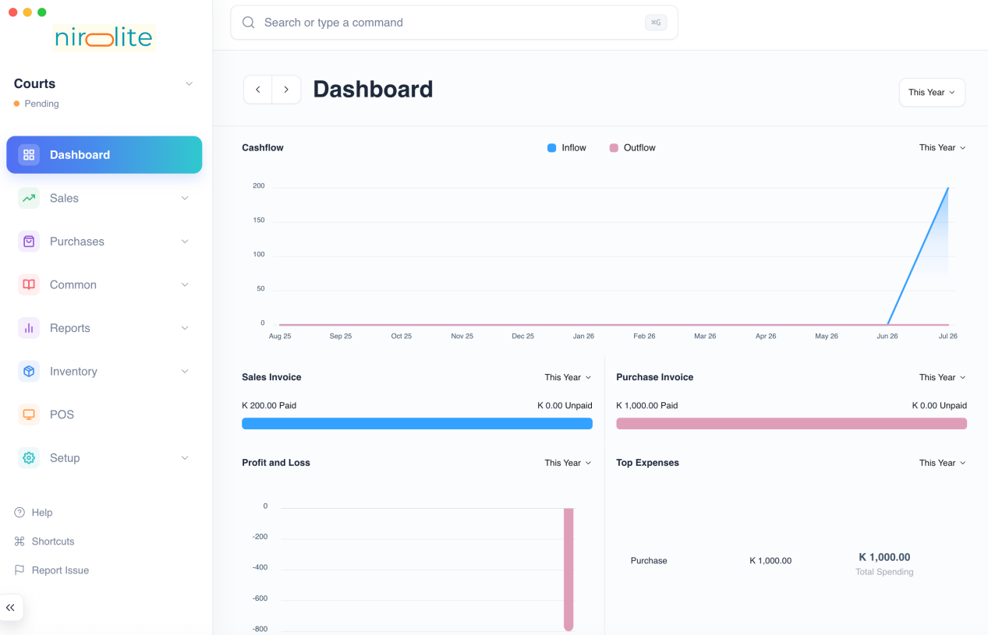

Period Selector
All sections of the Dashboard have a Period Selector. The default value is This Year. There are three options.
Consider today's date as 16 Jun, 2022. The three options will show analytics for the given range:
# | Option | From | Until (Today)
1 | This Year | 16 Jun, 2021 | 16 Jun, 2022
2 | This Quarter | 16 Mar, 2022 | 16 Jun, 2022
3 | This Month | 16 May, 2022 | 16 Jun, 2022
::: info Options The Cashflow and the Profit and Loss chart don't show the This Month option. :::

Cashflow
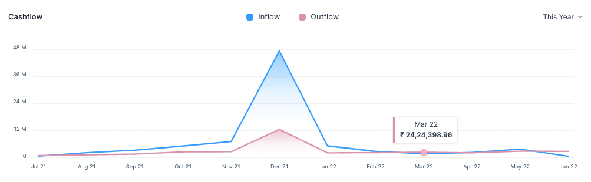
The Cashflow chart shows the total amount of money being transferred into and out of your company over a period.
::: tip Cashflow The Cashflow chart is calculated from the Cash and Bank account balances. :::
::: info Hover Hover tooltip shows the Inflow or Outflow amount for that month. :::

Pending Payments
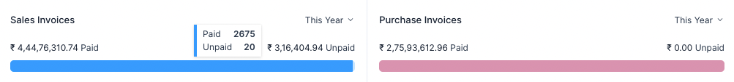
Pending Payments shows the invoice paid and unpaid (outstanding) amounts. It has two sub-sections
- The Sales Invoice section shows the total outstanding amount which is pending from your customers for your sales.
- The Purchase Invoice section shows the total outstanding amount that you have to pay to your suppliers for your purchases.
::: info Hover Hover tooltip shows the number of Paid and Unpaid invoices. :::

Profit and Loss
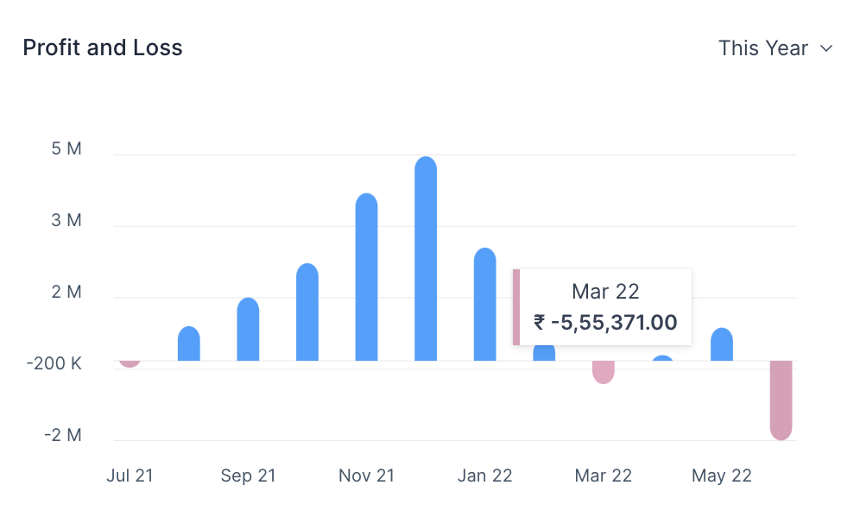This chart shows the profit (or loss) per month for a given period.
::: tip Profit and Loss Profit and Loss is the difference between the Income and Expense accounts. :::
::: info Hover Hover tooltip shows the Profit or Loss amount for that month. :::

Top Expenses
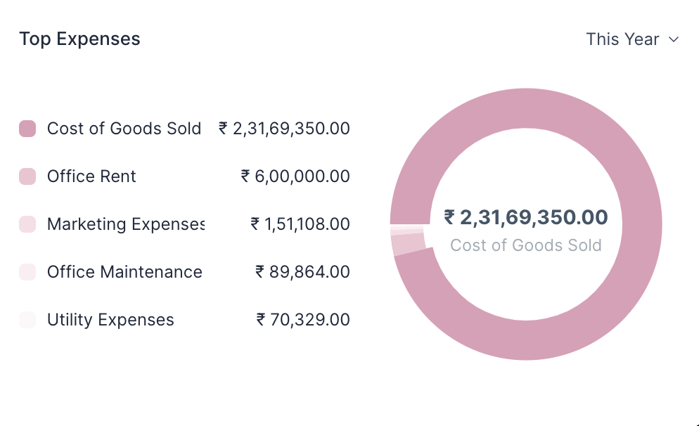
This section shows your top five expenses sorted from your highest expenses to lowest expenses by category.
::: tip Expenses The Top Expenses chart is calculated from the Expense account balances. :::

